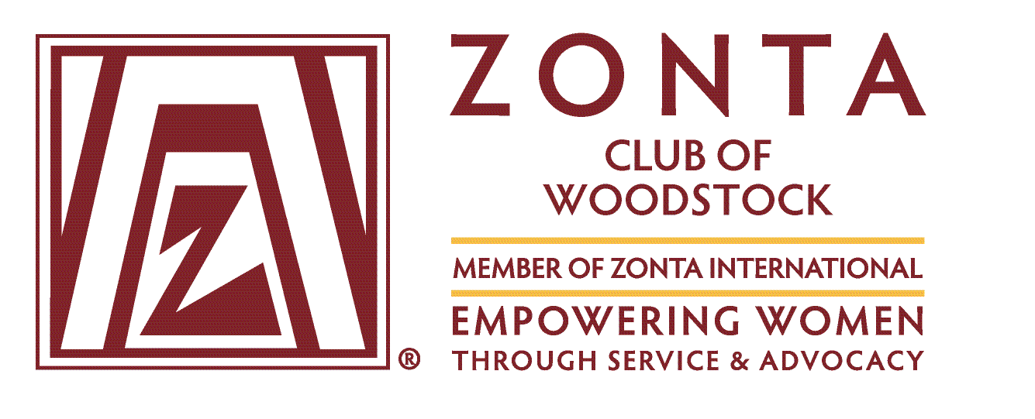

International Women’s Day
Annual Rose Sale Pre-Order Form

Purchasing yellow roses will acknowledge the women in your life & support Zonta projects.
 | Name | Single Rose $3.00 | Two Roses $5.00 | 12 Roses $30.00 | Delivery Address  Available for those ordering 12+ roses to one location,  unless a special arrangement has been made.  Thurs. Mar. 7th or Fri., Mar. 8th (please indicate) | Phone #
1
2
3
4
5
6
7
8
9
10
11
12
13
14
15
Roses are individually wrapped in cello. Bulk wrapping can be arranged. Rose pre-order deadline Sat., Mar. 2nd
For more information contact Sheena Poole at 519-536-3555 or zonta.woodstock@gmail.com.
Submit form with payment to Sheena Poole, a Zonta member, Mostly Roses, or to Zonta.woodstock@gmail.com. Cheques to: Zonta Club of Woodstock

Funds raised from the sale of roses will go to support Zonta International Programs

Zonta International Service Programs
Zonta International has contributed nearly US$19.2 million to projects benefiting women in 35 countries. The Zonta International Service Program has provided training, education, health, sanitation, agricultural and micro-credit assistance to women, primarily through projects implemented by the agencies of the United Nations and other recognized non-governmental organizations.

Eid bi Eid (Hand in Hand) Zonta International has committed US$1,000,000 to UN Women to improve Syrian refugee and Jordanian women’s access to sustainable and decent employment, coupled with protection services and community leadership/engagement, to enable greater equality and reduced violence against women.

Let Us Learn Madagascar: An Integrated Program for Adolescent Girls. Zonta International has committed US$1,000,000 to create opportunities for vulnerable and excluded girls to realize their rights to an education in a secure and protective environment. This project will promote a common vision of investing in junior secondary education for girls as an entry point for equity and focused on reaching out-of-school children, expanding girls’ education and improving quality outcomes for learners.

Zonta International Strategies to End Violence Against Women (ZISVAW) Programs
Programs have provided more than US$9.5 million to support projects to prevent and end violence against women and girls in 46 countries.

Ending Child Marriage. Zonta International has committed US$2,000,000 to UNICEF USA to support the UNICEF/UNFPA Global Programme to Accelerate Action to End Child Marriage in 12 countries: Bangladesh, Burkina Faso, Ethiopia, Ghana, India, Mozambique, Nepal, Niger, Sierra Leone, Uganda, Yemen and Zambia.
Child marriage is a global violation of human rights that can be found in cultures, religions, ethnicities and countries around the world. Recognizing that only a long-term strategy will ensure the desired outcomes, UNICEF and UNFPA have joined forces and formally launched a multi-country initiative to protect the rights of millions of the world’s most vulnerable girls. The Global Programme to Accelerate Action to End Child Marriage brings together governments, civil society, families and young people in a collective effort to prevent girls from marrying too young and to support those already married as girls.
To date, more than 1 million girls have been reached through life skills and school attendance support and 1.67 million individuals have been engaged in community-based behavior change and sensitization activities.

On behalf of the Zonta Club of Woodstock thank you for your support and acknowledging the women in your life.

